

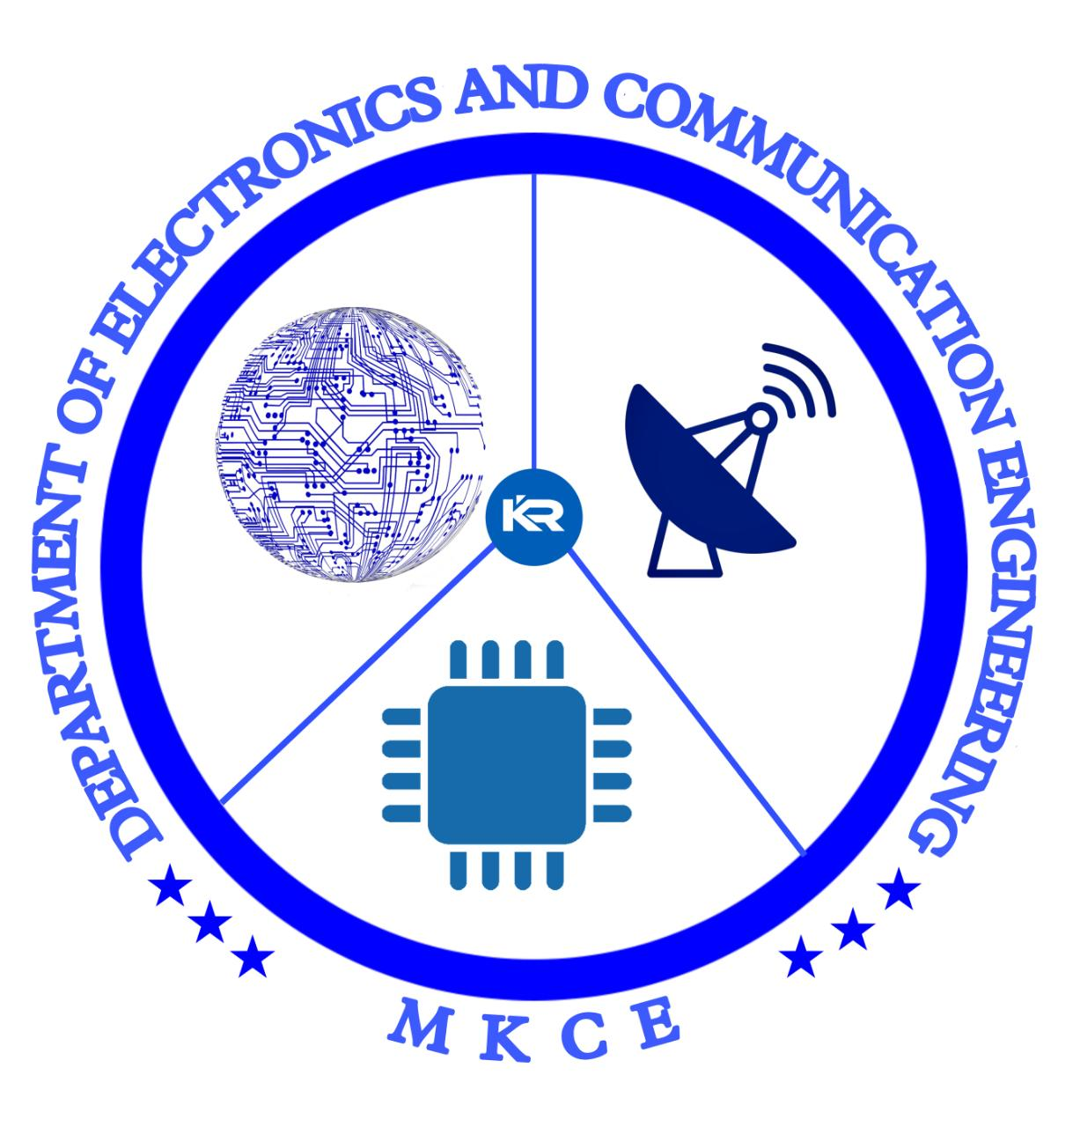
+

IOT BASED ELECTRICITY ENERGY METER

A MINOR PROJECT-II REPORT

Submitted by

YUVA SHREE R (927621BEC252)
SRUTHIKAA KV (927621BEC212)
SUGANYA DEVI S (927621BEC220)
SOWMIGA B (927621BEC207)

BACHELOR OF ENGINEERING

in
DEPARTMENT OF ELECTRONICS AND COMMUNICATION ENGINEERING

M.KUMARASAMY COLLEGE OF ENGINEERING
(Autonomous)

KARUR – 639 113

APRIL 2023
1 M.KUMARASAMY COLLEGE OF ENGINEERING, KARUR

BONAFIDE CERTIFICATE

Certified that this 18ECP103L-Minor Project I report “IOT BASED ELECTRICITY ENERGY METER” is the bonafide work of “YUVA SHREE R (21BEC252), SRUTHIKAA KV (21BEC212), SUGANYA DEVI S (21BEC220), SOWMIGA B(21BEC207) ” who carried out the project work under my supervision in the academic year 2023-2024.

SIGNATURE SIGNATURE
Dr.S.PALANIVELRAJAN, M.E., Ph.D., MS.SANMUGAVALLI,.
HEAD OF THE DEPARTMENT, SUPERVISOR,
Professor, Assistant Professor,
Department of Electronics and Department of Electronics and
Communication Engineering, Communication Engineering, M. Kumarasamy College of Engineering, M.Kumarasamy College of Engineering, Thalavapalayam, Karur-639113. Thalavapalayam, Karur-639113.

This Minor project-I report has been submitted for the 18ECP103L – Minor Project-II Review held at M. Kumarasamy College of Engineering, Karur on ______________.

2
PROJECT COORDINATOR

Vision of the Institution
To emerge as a leader among the top institutions in the field of technical education
Mission of the Institution
M1: Produce smart technocrats with empirical knowledge who can surmount the global challenges
M2: Create a diverse, fully engaged, learner-centric campus environment to provide quality education to the students
M3: Maintain mutually beneficial partnerships with our alumni, industry, and Professional associations Vision of the Department
Vision of the Department
To empower the Electronics and Communication Engineering students with emerging technologies, professionalism, innovative research, and social responsibility.
Mission of the Department
M1: Attain the academic excellence through innovative teaching learning process, research areas & laboratories and Consultancy projects.

M2: Inculcate the students in problem solving and lifelong learning ability. 3
M3: Provide entrepreneurial skills and leadership qualities.
M4: Render the technical knowledge and skills of faculty members.

Program Educational Objectives (PEOs):
PEO1: Core Competence: Graduates will have a successful career in academia or industry associated with Electronics and Communication Engineering.
PEO2: Professionalism: Graduates will provide feasible solutions for the challenging problems through comprehensive research and innovation in the allied areas of Electronics and Communication Engineering.
PEO3: Lifelong Learning: Graduates will contribute to the social needs through lifelong learning, practicing professional ethics and leadership quality
Program Outcomes (POs):
PO 1: Engineering knowledge: Apply the knowledge of mathematics, science, engineering fundamentals, and an engineering specialization to the solution of complex engineering problems.
4
PO 2: Problem analysis: Identify, formulate, review research literature, and analyze complex engineering problems reaching substantiated conclusions using first principles of mathematics, natural sciences, and engineering sciences.
PO 3: Design/development of solutions: Design solutions for complex engineering problems and design system components or processes that meet the specified needs with appropriate consideration for the public health and safety, and the cultural, societal, and environmental considerations.
PO 4: Conduct investigations of complex problems: Use research-based knowledge and research methods including design of experiments, analysis and interpretation of data, and synthesis of the information to provide valid conclusions.
PO 5: Modern tool usage: Create, select, and apply appropriate techniques, resources, and modern engineering and IT tools including prediction and modeling to complex engineering activities with an understanding of the limitations.
PO 6: The engineer and society: Apply reasoning informed by the contextual knowledge to assess societal, health, safety, legal and cultural issues, and the consequent responsibilities relevant to the professional engineering practice.

5
PO 7: Environment and sustainability: Understand the impact of the professional engineering solutions in societal and environmental contexts, and demonstrate the knowledge of, and need for sustainable development.
PO 8: Ethics: Apply ethical principles and commit to professional ethics and responsibilities and norms of the engineering practice.
PO 9: Individual and teamwork: Function effectively as an individual, and as a member or leader in diverse teams, and in multidisciplinary settings.
PO 10: Communication: Communicate effectively on complex engineering activities with the engineering community and with society at large, such as, being able to comprehend and write effective reports and design documentation, make effective presentations, and give and receive clear instructions.
PO 11: Project management and finance: Demonstrate knowledge and understanding of the engineering and management principles and apply these to one’s own work, as a member and leader in a team, to manage projects and in multidisciplinary environments.
PO 12: Life-long learning: Recognize the need for and have the preparation and ability to engage in independent and life-long learning in the broadest context of technological change.

6
Program Specific Outcomes (PSOs):
PSO1: Applying knowledge in various areas, like Electronics, Communications, Signal processing, VLSI, Embedded systems etc., in the design and implementation of Engineering application.
PSO2: Able to solve complex problems in Electronics and Communication Engineering with analytical and managerial skills either independently or in team using latest hardware and software tools to fulfil the industrial expectations

Program Specific Outcomes
PSO1: Applying knowledge in various areas, like Electronics, Communications, Signal processing, VLSI, Embedded systems etc., in the design and implementation of Engineering application.
PSO2: Able to solve complex problems in Electronics and Communication Engineering with analytical and managerial skills either independently or in team using latest hardware and software tools to fulfil the industrial expectations.

7

ABSTRACT

In this project, we will learn how to make our own IoT Based Electricity Energy Meter using ESP32 & monitor data on the Blynk Application. Earlier we built GSM Prepaid Energy Meter. With the current technology, you need to go to the meter reading room and take down readings. Thus monitoring and keeping track records of your electricity consumption is a tedious task. To automate this, we can use the Internet of Things. The Internet of Things saves time and money by automating remote data collection. Smart Energy Meter has received quite a lot of acclaim across the globe in recent years.We need to select the current sensor as well as the voltage sensor so that the current & voltage can be measured and thus we can know about the power consumption & total power consumed. The best current sensor available in the market is SCT-013. This is SCT-013 Non-Invasive AC Current Sensor Split Core Type Clamp Meter Sensor which can be used to measure AC current up to 100 amperes. Similarly, the best voltage sensor is the AC Voltage Sensor Module ZMPT101B. The ZMPT101B AC Voltage Sensor is the best where we need to measure the accurate AC voltage with a voltage transformer.Using the SCT-013 Current Sensor & ZMPT101B Voltage Sensor, we can measure the all required parameters needed for Electricity Energy Meter. We will interface the SCT-013 Current Sensor & ZMPT101B Voltage Sensor with Voltage Sensor is the best where we need to measure the accurate AC voltage with a voltage transformer.Using
SCT-013 Current Sensor & ZMPT101B Voltage Sensor, we can measure the all required parameters needed for Electricity Energy Meter. We will interface the SCT-013 Current Sensor & ZMPT101B Voltage Sensor with ESP32 Wifi Module & Send the data to Blynk Application. The Blynk Application Dashboard will display the Voltage, Current, Power & total unit consumed in kWh.

8
 | CONTENTS PAGE NO.
INSTITUTION VISION AND MISSION  DEPARTMENT VISION AND MISSION DEPARTMENT PEO, PO AND PSO  ABSTRACT  LIST OF TABLES  LIST OF FIGURES  LIST OF ABBREVIATIONS  INTRODUCTION  - OBJECTIVE  - HARD WARE COMPONENTS  LITERATURE REVIEW  3.2 PROPOSED SYSTEM  PROJECT METHODOLOGY  4.1 WORKING PRINCIPLE  RESULT AND DISCUSSION  CONCLUSION  REFERENCE |  | 3  3  4  8  10  10  11  12  15  17  18  19

TABLE OF CONTENTS

LIST OF FIGURE

TABLE No. | TITLE | PAGE No.
1.  2.  3. | Node MCU  LCD Display  Wifi Module | 13  14  15

LIST OF ABBREVIATIONS
MCU -Micro Controller Unit
Wi-Fi -Wireless Fidelity
IR-Infrared

10
CHAPTER 1

INTRODUCTION
The Internet of things concept enables us to connect the normal day to day devices with each other over the internet. The devices connected through IOT concept can be controlled and analysed remotely. The IOT concept provides the basic infrastructure and opportunities to form a connection between the physical world and computer based systems. The concept has been gaining importance with more and more wireless devices that are increasing rapidly in the market. It connects the hardware devices with each other over the internet. The ESP 8266 Wi-Fi module used in the system provides the connectivity with the internet in the system. Now-a-days the demand for electricity is increasing at a constant rate throughout the population and is being utilized for various purposes wiz, agriculture, industries, household purposes, hospitals etc. So, it is becoming more and more complicated to handle the electricity maintenance and requirements [3]. Therefore there is an immediate requisite to save as much electricity as possible. As the demand from the newer generations of population for electricity is increasing so in accordance with it the technology improvement is needed. The proposed system provides a technical twist to the normal energy meters using the IOT technology. Also there are other issues that we have to address such as power theft and meter tampering which in turn generate economic loss to the nation. Monitoring, Optimized power usage and reduction of power wastage are the major objectives that lie ahead for a better system. The present system vastly depends on human involvement for billing. Billing requires a human individual to visit each and every customer’s energy meter and generate the bill by taking the unit readings from the energy meter. This is a time consuming process. , In India,the electricity usage is very high. And there is no such system that can take the reading on its own. Energy meter monitoring and keeping track of energy consumption is generally done manually. This process is quite complex, it sometimes produces few problems due to human errors. The problems such as retaking reading may cause, but the bigger problem is in case of big apartment. In these apartments as there are a number of residents and everyone is having an Energy Meter, the number of meters is also high. These meters are connected in matrix form. So, it is quite difficult for both the electricity board and the consumer to identify their own meter. Also for the consumer to know his daily use of electricity, has to go to the meter and check for the readings, which makes this stuff a bit annoying . So, automating this process will be very useful. This will allow user to monitor reading by the internet access. This automated system is such designed that it can access the Energy Meter of every consumer directly without any human intervention. It will take the reading itself and will display it using server this will make consumer also to access their account on server and check their usage and bill even on daily basis and at will disconnect the connection if bill is not paid in time. Automated system will provide unit consumed and the cost of the unit. This also will be useful for the smart city programme undertaken by government. This paper is presenting the automated Electric Energy Meter inspecting and billing system. This system will help creating a transparent and a consumer-friendly environment
12

  - OBJECTIVE
This technology is used to create the connection in physical objects with various software and sensor devices. Using this IoT concept, every device can transfer the data between them. This smart meter automatically reads the electrical consumption from the user's meter device and transfers the data to the server. The traditional way of taking meter reading is by using human intervention. In this process of taking meter reading a person from the electricity board takes the photo of the meter having the reading. Then this reading from the photo is submitted at board and depending upon the previous reading bill is made . This process is a monthly process, so consumer never get to know the electricity usage from the bill for the desired time span unless he checks the Energy meter himself. So this process sometimes produces inconvinience in the mind of the consumer about the bill. Also it is difficult for the person taking the meter reading to take the reading in big apartments as the meters are connected in matrix form. The major cause of this problem is human intervention so to eliminate this problem it is desired to eliminate this human intervention. And this is done by
automating this system.

  - HARD WARE COMPONENTS REQUIRED

1.Power supply

2.Node MCU

3.Alarm

4.IOT

5.LCD Display
6.Wifi Module
1.POWER SUPPLY:

Power supply is an integral parts a vital role in every electronic system and hence their design constitutes a major part in every application. In order to overcome mal-operation which results due to fluctuations in the load and discontinuity in the supply proper choice of power supply.

  - NODE MCU:
NodeMCU is an open source firmware for which open source prototyping board designs are available. The name "NodeMCU" combines "node" and "MCU" (micro-controller unit). Strictly speaking, the term "NodeMCU" refers to the firmware rather than the associated development kits.
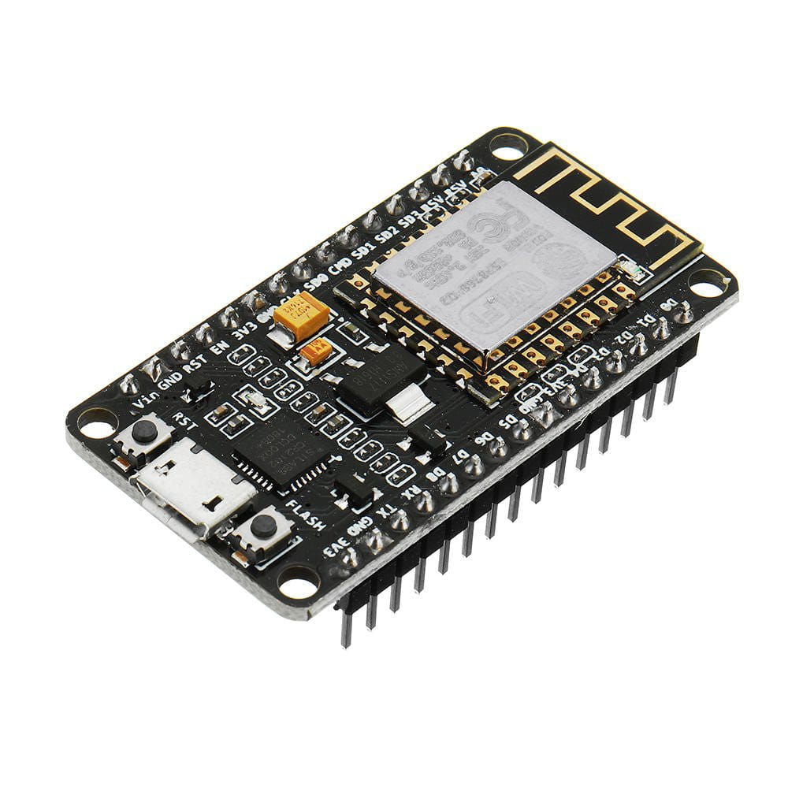
Figure 1: Node MCU
  - ALARM: A buzzer or beeper is a signalling device.It most commonly consists of a number of switches or sensors connected to a control unit that determines if and which button was pushed or a preset time has lapsed, and usually illuminates a light on the appropriate button or control panel, and sounds a warning in the form of a continuous or intermittent buzzing or beeping sound. Initially this device was based on an electromechanical system which was identical to an electric bell without the metal gong (which makes the ringing noise).

1.5 IOT:
The internet of things, or IoT, is a system of interrelated computing devices, mechanical and digital machines, objects, animals or people that are provided with unique identifiers (UIDs) and the ability to transfer data over a network without requiring human-to-human
or human-to-computer.
An Internet of Things (IoT) gateway is a physical device or software program that serves as the connection point between the cloud and controllers, sensors and intelligent devices.

1.4 LCD DISPLAY:
Liquid crystal displays (LCDs) have materials which combine the properties of both liquids and crystals. Rather than having a melting point, they have a temperature range within which the molecules are almost as mobile as they would be in a liquid, but are grouped together in an ordered form similar to a crystal.
An LCD consists of two glass panels, with the liquid crystal material sand witched in between them. The inner surface of the glass plates are coated with transparent electrodes which define the character, symbols or patterns to be displayed polymeric layers are present in between the electrodes and the liquid crystal, which makes the liquid crystal molecules to maintain a defined orientation angle.
One each polarisers are pasted outside the two glass panels. These polarisers would rotate the light rays passing through them to a definite angle, in a particular direction

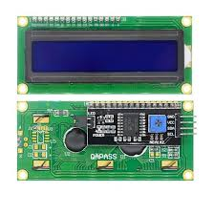
Figure 2: LCD Display

WIFI MODULE:

Wifi modules or wifi microcontrollers are used to send and recieve data over Wi-Fi. They can also accept commands over the Wi-Fi. Wi-Fi modules are used for communications bewtween devices. They are most commonly used in the field of Internet of Thnigs..
The ESP8266 module works with 3.3V only, anything more than 3.7V would kill the module hence be cautions with your circuits. The best way to program an ESP-01 is by using the FTDI board that supports 3.3V programming. If you don’t have one it is recommended to buy one or for time being you can also use an Arduino board. One commonly problem that every one faces with ESP-01 is the powering up problem. The module is a bit power hungry while programming and hence you can power it with a 3.3V pin on Arduino or just use a potential divider. So it is important to make a small voltage regulator for 3.31v that could supply a minimum of 500mA.

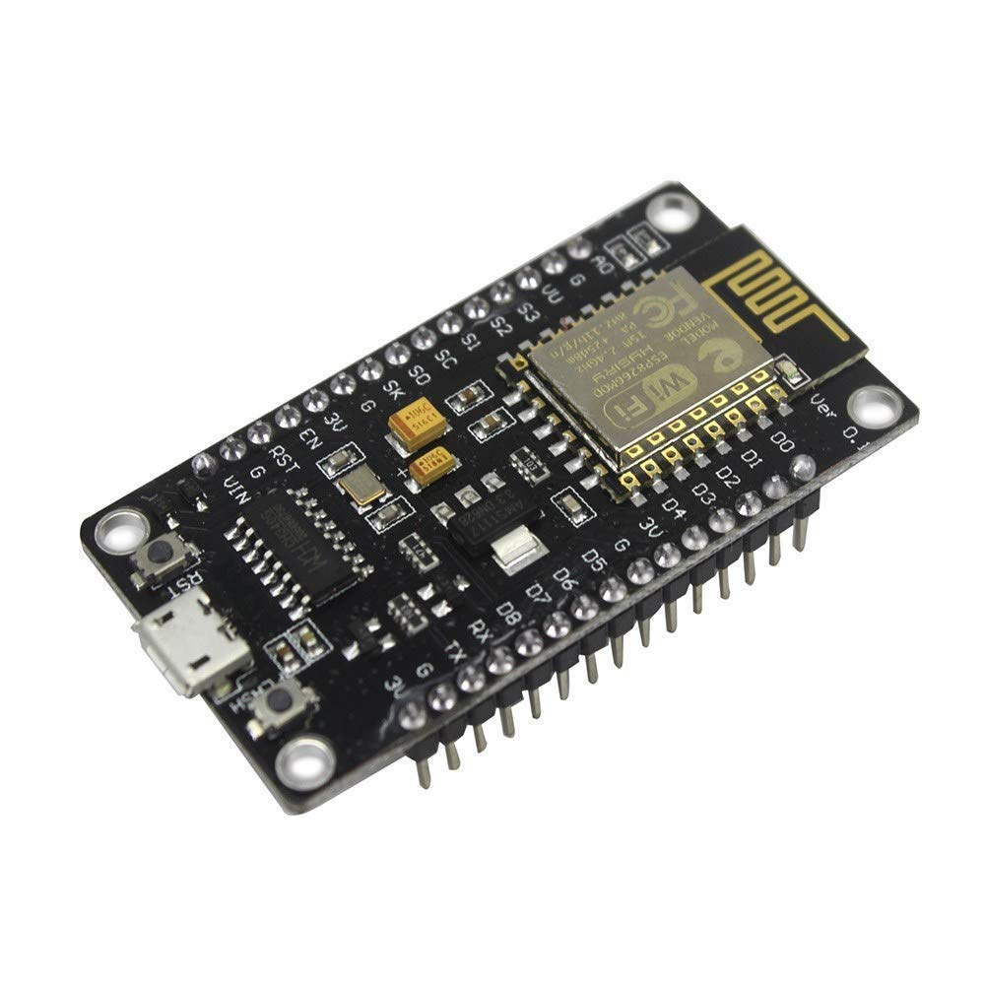
Figure 3:Wifi Module

CHAPTER 2
LITERATURE REVIEW

22

3.2 Proposed system

Monitoring and keeping tracking of your electricity consumption for verification is a tedious task today since you need to go to meter reading room and take down readings. Well it is important to know if you are charged accordingly so the need is quite certain. Well we automate the system by allowing users to monitor energy meter readings over the internet. Our proposed system uses energy meter with microcontroller system to monitor energy usage using a meter.
The meter is used to monitor units consumed and transmit the units as well as cost charged over the internet using wifi connection. This allows user to easily check the energy usage along with the cost charged online using a simple web application. Thus the energy meter monitoring system allows user to effectively monitor electricity meter readings and check the billing online with ease.

23

CHAPTER 4
PROJECT METHODOLOGY

4.1 WORKING PRINCIPLE :
A smart power meter takes automatic readings of your residential, commercial, or industrial electricity usage and relays the information wirelessly to your energy supplier. Initially the count will be zero. And then it will count ahead. As soon as counter value reaches to 3200 , then a command will passed to the server to increase unit by + 1. This is done by using Wi-fi module. A website is created so as to display this data on the internet. This website will be connected with server, so that whenever data will change in database it will show the actual reading of meter accordingly. The consumer will access his own reading by using a unique code given for each Energy meter.
The meter is used to monitor units consumed and transmit the units as well as cost charged over the internet using wifi connection. This allows user to easily check the energy usage along with the cost charged online using a simple web application.

CHAPTER 5
RESULT AND DISCUSSION
This experiment results both hardware and software part.
First of all, the LED blinking has been successfully coupled to the counter of the microcontroller by the optocoupler.
Then this data is being displayed by the Wi-Fi module on server on the internet.
The user interface of website accessed by consumer is shown in fig. 4 & fig. 5 as follows.
HyperText markup language, HTML is front end language. It is the part which is visible to the user.
It may consist of GUI which provides better user interface for the user. PHP is a general-purpose scripting language that is especially suited to server-side web development, in which case PHP generally runs on a web server.
Any PHP code in a requested file is executed by the PHP runtime, usually to create dynamic web page content or dynamic images used on websites or elsewhere [14].
PHP is basically back end language. Its main task is to connect html page to actual remote webserver.
It acts as interface between user window and actual server(database). Fig. 4. Website window for Id Entry Fig. 5. Website window for Energy Meter readings.

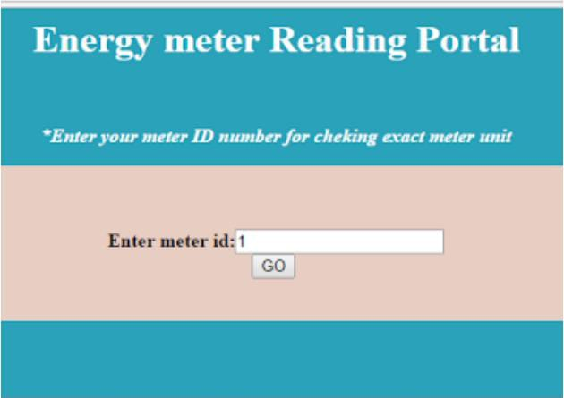

Fig.4.Website window for Id Entry

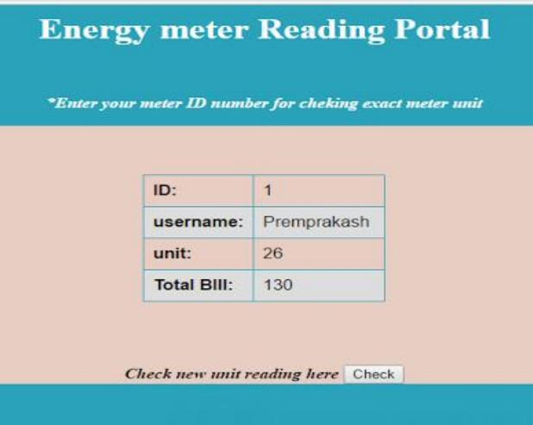

Fig.5.Website window for Energy Meter readings

26
CHAPTER 6

CONCLUSION

An attempt has been made to make a practical model of ‘IoT Based Smart Energy Meter.’ The propagated model is used to calculate the energy consumption of the household, and even make the energy unit reading to be handy.
Hence it reduces the wastage of energy and bring awareness among all. Even it will deduct the manual intervention.

CHAPTER 7

REFERENCE

[1] M. Prathik, K. Anitha and V. Anitha, "Electricity Energy Meter Surveillance Using IoT," 2018 International Conference on Power, Energy, Control and Transmission Systems (ICPECTS), Chennai, India, 2018, pp. 186-189, doi: 10.1109/ICPECTS.2018.8521650.
[2] H. K. Patel, T. Mody and A. Goyal, "Arduino Based Electricity Energy Meter using GSM," 2019 4th International Conference on Internet of Things: Smart Innovation and Usages (IoT-SIU), Ghaziabad, India, 2019, pp. 1-6, doi: 10.1109/IoT-SIU.2019.8777490.
[3] Md. Masudur Rahman, Noor-E-Jannat, Mohd. Ohidul Islam and Md. Serazus, “Arduino and GSM based Electricity energy meter for advanced metering and billing system”, Institute of Electrical and Electronics Engineers (IEEE), 2015.
[4] S. Visalatchi and K Kamal Sandeep, “Electricity energy metering and power theft control using Arduino & GSM”, Institute of Electrical and Electronics Engineers (IEEE), 2017.
[5] Gobhinath. S, Gunasundari. N and Gowthami. P, “Internet of Things (IoT) Based Energy Meter”, International Research Journal of Engineering and Technology (IRJET), 2016.
[6] P. V. Santhosh Roja, B. Kiran Babu and V. Samson Deva Kumar, “Wireless Energy Meter and Billing via SMS”, International Journal of Science and Research (IJSR), 2013.
[7] Vanishree k Rao and Sri G N Madhu, “GSM based Energy Meter Reading and Billing”, International Journal of Science and Research (IJSR), 2016.
[8] Pritee Mahajan, Sneha Tatia and Prachi Jadhav, “Electricity Energy Meter: An IOT Based Meter for Live Electricity Monitoring and Bill Payment”, International Journal of Electrical, Electronics and Computer Systems (IJEECS), 2017.
[9] Rikta Majumder, Sukdev Dolui, Debasis Agasti, Surajit Biswas, Micro-controller Based Over Current Relay Using Hall Effect Current Sensor, 2018 Emerging Trends in Electronic Devices and Computational Techniques (EDCT)
[10] T. K. Gannavaram V and R. Bejgam, "Brief Study and Review on the Next Revolutionary Autonomous Vehicle Technology," 2021 International Conference on Advance Computing and Innovative Technologies in Engineering (ICACITE), 2021, pp. 34-37, doi: 10.1109/ICACITE51222.2021.9404763.
[11] T. K. Gannavaram V, R. Bejgam, S. B. Keshipeddi, A. Banda and G. Bollu, "Study of Automobile Safety Technology Development using Vehicular Safety Device (VSD)," 2021 6th International Conference on Inventive Computation Technologies (ICICT), 2021, pp. 240-244, doi: 10.1109/ICICT50816.2021.9358670.
[12] T. K. Gannavaram V, U. Maheshwar Kandhikonda, R. Bejgam, S. B. Keshipeddi and S. Sunkari, "A Brief Review on Internet of Things (IoT)," 2021 International Conference on Computer Communication and Informatics (ICCCI), 2021, pp. 1-6, doi: 10.1109/ICCCI50826.2021.9457009.
[13] T. K. Gannavaram V, U. M. Kandhikonda, R. Bejgam, S. B. Keshipeddi and S. Sunkari, "A Brief Review on Internet of Things (IoT)," 2021 International Conference on Computer Communication and Informatics (ICCCI), 2021, pp. 1-6, doi: 10.1109/ICCCI50826.2021.9451163.

29

